

SOFTWARE REQUIREMENT SPECIFICATION

WEB CHAT APPLICATION



DONE BY

111522204013- DHARSHINI. K 11152222204019- JEYAVANI.H 111522204022- KALAIVANI.V

Software requirement specification (SRS) for web application- chatting

**1. INTRODUCTION:**

PURPOSE:

The chat server management system is a software that enables users to engage in private and public conversations, with one another or as a group all over the world. It provides encrypted communication between users via video calls, by sending images, documents, and user locations. This data is further processed for backup management. This project is centered on the development that would allow users to properly log in, send messages, and perform system maintenance.

SCOPE:

This application works on multiple devices by sharing the same database, which users of different domains use synchronously. It allows the user to exchange messages and documents at normal internet speed, free of cost over the internet.

**DEFINITIONS:**

SRS- Software Requirement Specification

LAN- Local Area Network

**OVERALL DESCRIPTION**:

The chat server management system is developed for communication via text messages, voice calls, and group chats and is also responsible for tracking the user’s fast and encrypted communication.

The administrator will have to maintain the following:

* User details
* User history
* User chat and friend list

The administrator will perform the following functions:

* Notification
* Login and logout management

The user requires the following information to access the application:

* Login ID
* Login password

**PRODUCT PERSPECTIVE:**

The system developed here is a centralized system. It has a client-server system with a centralized database server. All local clients are connected to a centralized server via LAN.

GENERAL CONSTRAINTS

Internet connection is required to access this application.

PRODUCT FUNCTIONS

Use case diagram:

* **Domain constraints:**
* The application does not by any means open the web browser. If

user wishes to open the web browser he must open it externally.

* The system needs to be permanent connected with internet.

**SPECIFIC REQUIREMENTS:**

1. **Functional requirements:**

* This section provides requirements overview of the system.
* Various functional modules that can be implemented by the system will be:

Description:

* Login:
* The user should login into the app by entering their mail id and password to create an account Logout:

The user can logout their account whenever they want.

* Profile:

The user should update their profile.

* Group chat:

The user can create a group with a maximum limit of 120 members in a group.

* Send message:

The user can send the message to anyone.

* Add and block friend:

The user can add a friend and he can also block a friend who he

Doesn’t want to chat with them.

* Delete message:

The user can delete the message through the delete option.

Feedback The use can give feedback about the application.

1. **Non - functional requirements:**

* Following Non - functional requirements will be there in the insurance to the internet:
* Privacy:

Encryption allows users to safety transmit personal or business information over the internet.

* Performance:

The application performance must be better.

* Portability:

Application must be able to run in many different system.

* Usability:

To make able to use even for newbie.

* Supportability:

To be capable of being supportive.

**TECHNICAL ISSUE:**

This system will work on client server architecture. It will require an internet server and which will be able to run PHP application. The system commonly used browser such as Mozzila firefox, chrome etc.

**INTERFACE REQURIEMENT:**

* Login page
* Registration form
* There will be a screen displaying chat option, add friend option.
* The feedback page will open to give share their opinion about the application.

**SOFTWARE REQUIREMENTS:**

* Processor: Intel Platinum 4 or later.
* Memory: 2GB, 4GB recommended.
* Operating System: 64bit Fedora Linux 24+
* Screen resolution: 1280*1024 or larger.
* Application window size: 1024*680 or larger.
* Internet connection: Required.

**HARDWARE REQUIREMENTS:**

* Note pad++ is a text editor and source code editor and pervious an environment for developing HTML, JSP, JavaScript, many other editing purposes.
* Coding is done in java so required JDK and above for run java programs.
* Operating system such as windows 7,8,XP,Linux etc.

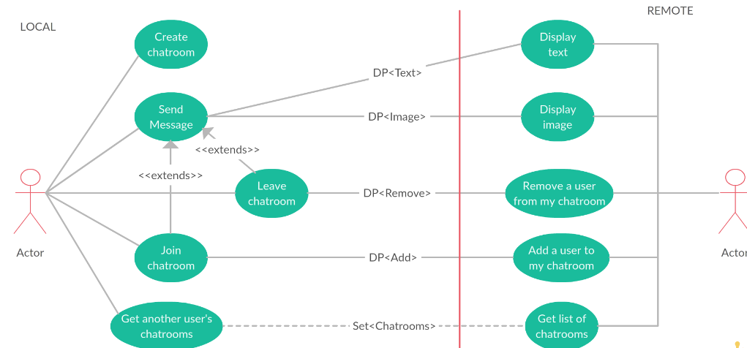

**CONCLUSION:**

This chat server management system is developed for communication via text messages, voice calls, and group chats and is also responsible for tracking the user’s fast and encrypted communication. It also allow users to access high-quality user interface.In future we may also have extended features in this system.